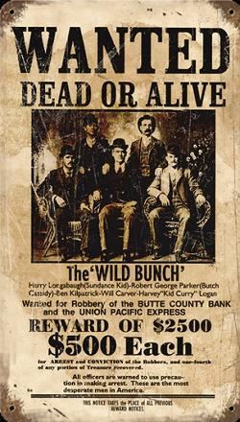

**Tasks:**

**Collaborate with two-three persons in your classroom**

1. **Make an outline of a scenario of your choice (a list of ideas are given) and create a story (homework). Choose two outlaws from the list given.**
2. **Create your own *Wanted* poster for one of your group members, think of a ‘crime’, reward, nickname, etc...**

**List of Ideas for Scenario**

Create your own scenario of an adventure with the setting of the Old West.

You will use the outlaw of you and your partners’ choices (two outlaws).

* Cattle rustlers
* Horse thieves
* Bank robbers
* Train robbers
* Shooting at the O.K. Corral
* Striking gold
* Indian territory

You should have a beginning with a description of your setting, a middle (determining a climax) and an ending or demise, telling what happens between the two character outlaws from the beginning to the end.

Best group will be awarded!

**List of Outlaws**

Jesse James

Henry Antrim (Billy the Kid)

David C. Anderson

James Anderson

John King Fisher

David Atkins

Kate Watson (Cattle Kate)

Richard "Rattlesnake" Barter

Samuel "Sam" Bass

Pearl Hart

Laura Bullion (Della Rose)

William Carver

Butch Cassidy

Christopher "Kit" Carson Joy

Samuel "Sam" Ketchum

Thomas E. "Black Jack" Ketchum

Bill McCarty

George "Bitter Creek" Newcomb

Robert "Bob" A. Olinger (Pecos Bob)

Iron Jack Sheet

George Shephard

"Kid" Wade

Erastus "Red" Yage

**Example:**

Billy the Kid was said to be in town. Kit Carson was at the saloon asking about the notorious outlaw. He had been looking for a partner ever since he heard that there was a train coming into town carrying a surplus of guns and ammunition.

Avoiding the sheriff, Billy the Kid was hanging low, out of sight. Kit Carson found the Kid hold up in a cavern just outside of the town. In collaboration, they came up with a plan to rob the train before it comes into the town.

The train is heard miles down the track as Kit and Billy get ready to ambush the train. They pull their bandannas up around their faces, and with guns fireing they take both sides of the train.

Kit caught a bullet in the leg, Billy got a shot off at a guard who went tumbling off the train before it came to a complete halt. The outlaws rallied up the trainmen, tied them together and it made off with two large boxes of guns and ammunition.

Soon on their trail was the sheriff’s posse. After a chase under the blazing sun, experienced as they were, Kit and Kid managed to get fresh horses and the posse could not keep up with them anylonger.

**List A rubric is provided to show criteria that need to be completed.**

**Have fun and use your imagination!**