Clara Barton  1812-1912  HUMANITARIAN AND FOUNDER OF THE RED CROSS  Barton was one of America's greatest humanitarians, a nurse during the Civil War who became president of the Red Cross. | 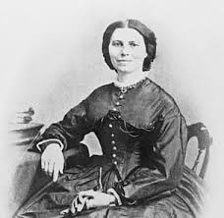
Susan Solomon  1956-  ATMOSPHERIC SCIENTIST  A senior scientist at the National Oceanic and Atmospheric Administration, she helped determine what caused the hole in the ozone layer. Her work led to the global ban on chemicals like the propellants in old-style aerosol cans. | 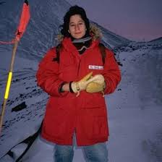
Meryl Streep  1949-  ACTRESS  By inhabiting completely and compellingly an amazing array of fascinating women, she's not only enlarged our world, but redefined excellence in a manner as entertaining as it is exhilarating. | 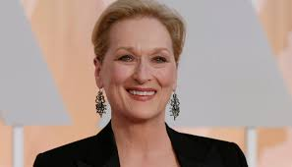
Janet Guthrie  1938-  RACE CAR DRIVER  Guthrie was the first woman to qualify and compete in the Daytona 500 in 1976 and the Indianapolis 500 in 1977. She is tied with Danica Patrick for the best finish by a woman in a top-tier NASCAR race. | 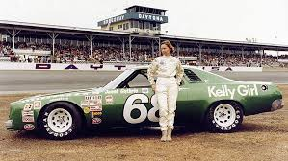
Valentina Tereshkova  1937-  COSMONAUT  Tereshkova was the first woman to go to space, in 1963. She is now a retired cosmonaut, engineer, and politician with numerous awards and honors. | 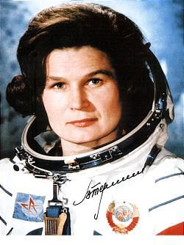
Gloria Steinem  1934-  JOURNALIST AND POLITICAL ACTIVIST  Known as one of today's most fascinating and influential women from her leadership in the '60s and '70s feminist movement, this famed female is still making history today. | 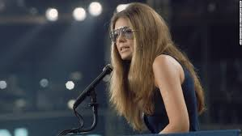
Toni Morrison  1931-  NOVELIST  The first African American to win the Nobel Prize for Literature; winner of the Pulitzer Prize. Her enthralling books illuminate the mysteries of the human heart and unflinchingly take on the toughest issues. | 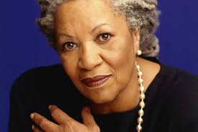
Maya Angelou  1928-2014  POET, SINGER, AND CIVIL RIGHTS ACTIVIST  Angelou was an iconic creative and activist who is best known for her influential series of autobiographies. She was also a leading force within the Civil Rights Movement alongside Martin Luther King, Jr. and Malcom X. | 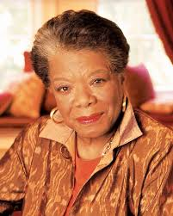
Helen Gurley Brown  1922-2012  EDITOR AND SEXUAL REVOLUTIONARY  Author of the 1962 mega best-seller Sex and the Single Girl and editor of Cosmopolitan for 32 years, she was an outspoken advocate for women's sexual freedom long before the idea went mainstream. | 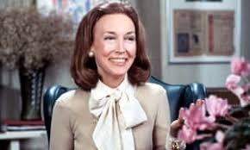
Rosalind Franklin  1920 -1958  BIOPHYSICIST  She discovered proof of the double-helix structure of DNA before the men credited with doing so, Francis Crick, James Watson, and Maurice Wilkins; their work was based in part on her data. They won a Nobel Prize; she died in obscurity at 37. Her full contribution wasn't acknowledged until years later. | 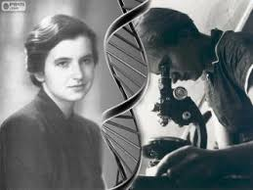
Katharine Hepburn  1907-2003  ACTRESS  Those cheekbones, those trousers, those four Best Actress Oscars (still a record). Most of all, that insistence upon Yankee self-reliance and gumption. We needed to see what casual confidence and no-nonsense independence looked like on a giant silver screen. | 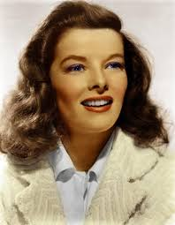
Jacqueline Cochran  1906-1980  PIONEERING PILOT  The first woman to break the sound barrier, she might have been the first woman astronaut — but apparently NASA wasn't ready: Thirteen women, including Cochran, were invited to train, then disinvited in 1961 (though some outperformed male trainees). | 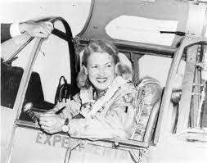
Amelia Earhart  1897-1939  AMERICAN AVIATOR  Amelia Mary Earhart took women's accomplishments to new heights — literally! Earhart not only was the first female aviator to fly alone across the Atlantic Ocean, but she was an author and also visiting teacher at Purdue University. She won a multitude of prestigious awards, namely the U.S. Distinguished Flying Cross. | 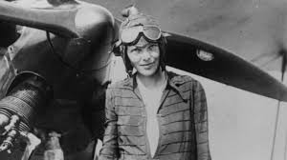
Virginia Woolf  1882-1941  NOVELIST AND ESSAYIST  She's known not just for being an important and inventive novelist, but for reminding us, in A Room of One's Own, of what remarkable things women might have written throughout history if they hadn't been too burdened by household chores and society's restrictions. | 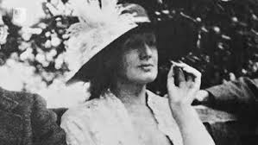
Georgia O'Keefe  1887-1986  ARTIST  With a life that was just as captivating as her art, O'Keeffe broke the all rules for female artists of her time. | 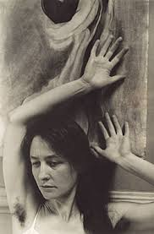
Margaret Sanger  1879-1966  BIRTH-CONTROL ADVOCATE  Sanger founded the American Birth Control League, which became Planned Parenthood. The sixth of 11 children — she felt that frequent pregnancies hastened her mother's early death — Sanger worked to give us control over the means of reproduction. | 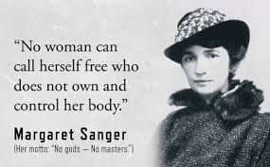
Helen Keller  1880-1968  WRITER, LECTURER, HUMAN RIGHTS CAMPAIGNER, PACIFIST  Rendered blind and deaf by a childhood illness, Keller was freed from her isolation by the extraordinary efforts of her dedicated teacher, Anne Sullivan (1866-1936), who suffered from impaired vision herself. Keller, the first deaf-blind person to earn a college degree, changed forever our ideas about what disabled people could accomplish. | 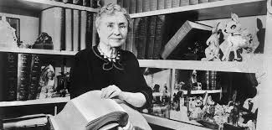
Nellie Bly  1864-1922  REPORTER  The nom de plume of reporter Elizabeth Cochrane Seaman, who got herself committed to an insane asylum to expose horrendous conditions, zipped around the globe, and covered WWI. Her probing and poking spurred official action, and her bold dispatches inspired budding girl writers. | 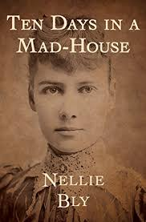
Annie Oakley  1860-1926  SHARPSHOOTER  Phoebe Ann Mosey joined Buffalo Bill's Wild West show in 1885, the same year Good Housekeeping was launched. She was a staunch supporter of women's rights, and female fans were tickled that she'd met her husband by beating him in a shooting match: Anything he could do, she could do better. | 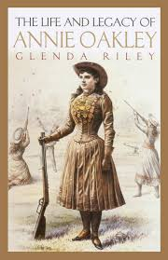
Mother Jones  1837-1930  LABOR LEADER  Mary Harris Jones, assailed in Congress as "the grandmother of all agitators," and hailed as "the miner's angel" by workers, fought against child labor and for decent conditions, fair pay, and safety in the workplace. | 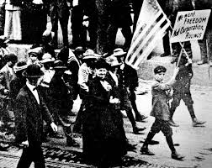
Jane Addams  1860-1935  SOCIAL REFORMER, NOBEL PEACE PRIZE WINNER  Social worker, miracle worker: The settlement house system she brought to the U.S. offered sustenance, safety, and services to thousands of the nation's underprivileged. | 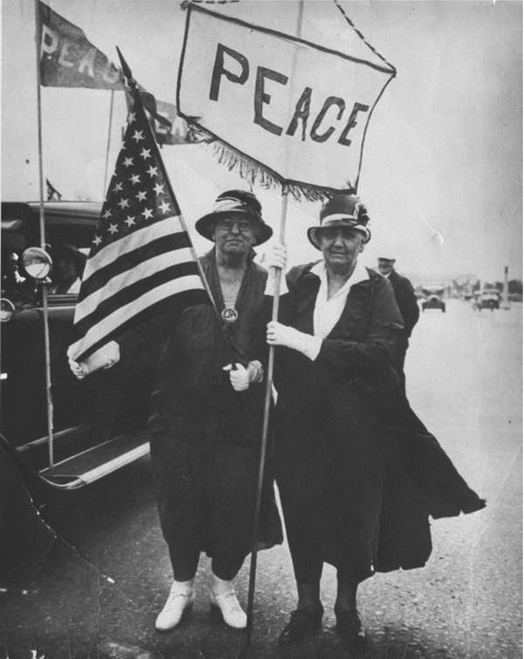
Diana, Princess of Wales  1961-1997  ROYAL AND HUMANITARIAN  Her legacy of charm and charity endures, especially her campaigns for acceptance of AIDS victims and against land mines. We remember most the uniting effect of the world's mourning after her sudden and shocking death. | 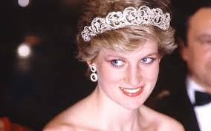
Sally Ride  1951-2012  ASTRONAUT AND ASTROPHYSICIST  The first American woman — finally — in space, 1983. Overall, Ride was the third woman in space after USSR. At the age of 32, she remains the youngest American astronaut to have travelled to space. | 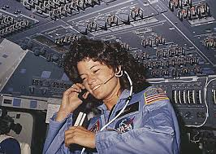
Jane Goodall  1934-  PRIMATOLOGIST AND CONSERVATIONIST  Fifty years ago she began studying chimpanzee families at the Gombe Stream National Park in Tanzania — and in the process taught us much about our own. Roots & Shoots, her environmental organization for kids, has tens of thousands of participants — a new generation ready to protect wild things and their habitats. | 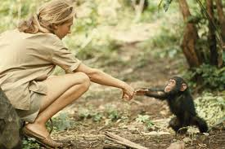
Wilma Rudolph  1940 -1994  OLYMPIAN  Rudolph was the first American woman to win three gold medals in track and field at a single Olympics. Read her dramatic autobiography about how she excelled to Olympic greatness. | 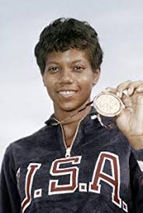
Madeline Albright  1937-  FORMER SECRETARY OF STATE  She became the female Secretary of State, in 1996. Albright currently serves as the chair of Albright Stonebridge Group and as a professor at Georgetown University. In 2012, she was awarded the Presidential Medal of Freedom by U.S. President Barack Obama. | 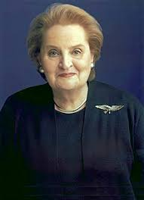
Billie Jean King  1943-  TENNIS CHAMPION  Winner of 39 Grand Slams (singles, doubles, and mixed doubles), founder of the Women's Sports Foundation — and trouncer of Bobby Riggs in 1973's "Battle of the Sexes." | 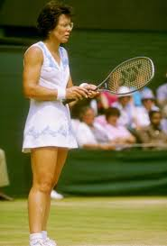
Barbara Walters  1929-  TV NEWSWOMAN  The first woman to co-anchor a network's nightly news (and earn an unprecedented $1 million a year for it), she's grilled the world's most intriguing people on our behalf. And hey — it was Katharine Hepburn who first mentioned that tree thing; Walters was just following up. | 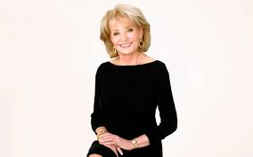
Margaret Thatcher  1925-  FIRST FEMALE PRIME MINISTER OF BRITAIN  Hearing the Iron Lady talk tough inspired us to stay strong too — whether we agreed with her or not. | 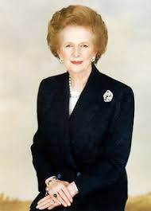
Marion Donovan  1917-1998  INVENTOR  Donovan came up with the prototype for the disposable diaper in the 1950s; others patented and marketed the idea. The environmentalist in us frowns; the mom in us weeps with gratitude. | 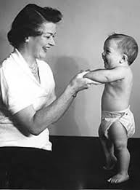
Gertrude Belle Elion  1918-1999  MEDICAL RESEARCHER  Thousands of cancer patients have been given a second chance because of her: This Nobel Prize-winning research scientist co-developed two drugs that fought leukaemia. In1957, she developed the first immunosuppressant agent, a development that made it possible to transplant organs. | 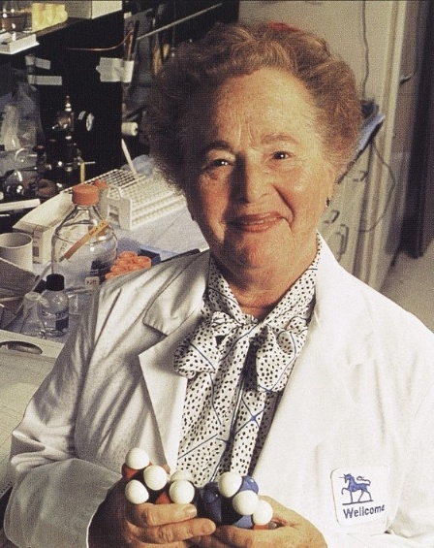
Grace Murray Hopper  1906-1992  COMPUTER-LANGUAGE CREATOR  One of the first women in the Navy to attain the rank of rear admiral, Hopper was a math whiz and a founding mother of computer languages; her focus was on making them more accessible to programmers. Your swift, snazzy software exists because of her. | 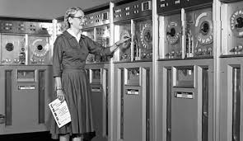
Caresse Crosby  1891-1970  INVENTOR  Crosby came up with the first modern bra, patented in 1914. Her real name was Mary Phelps Jacob, and she was also a publisher. | 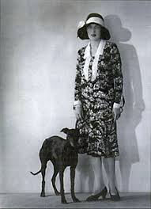
Marian Anderson  1897-1993  SINGER  In 1939, the DAR refused to let Anderson sing in DC's Constitution Hall because she was black. First Lady Eleanor Roosevelt resigned from the DAR, and her husband's administration arranged an outdoor concert at the Lincoln Memorial for a crowd of 75,000 and millions of radio listeners. Anderson was the first African American to sing with the Metropolitan Opera, and in 1958 became a delegate to the United Nations. | 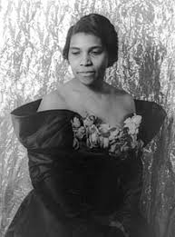
Coco Chanel  1883-1971  DESIGNER  Her personal life was complicated, her design credo simple and elegant: "Fashion fades; only style remains the same," she said. Mercifor the little black dress, the classy suit, No. 5, and plenty of je ne sais quoi. | 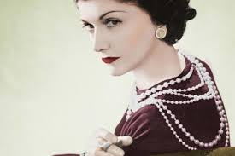
Madame C.J. Walker  1867-1919  BEAUTY MAGNATE  Born Sarah Breedlove, she created a line of beauty products for African-American women, eventually employing almost 3,000 women and becoming, it is believed, the first black woman millionaire in the United States. | 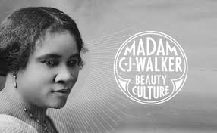
Isadora Duncan  1877-1927  DANCER  The mother of modern dance chafed under what she saw as the rigid restrictions of classical forms and replaced them with free, expansive, expressive movement. She influenced a generation of dancers — and loosened us all up. | 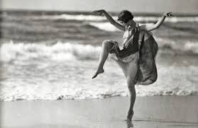
Marie Curie  1867-1934  NOBEL PRIZE-WINNING PHYSICIST AND CHEMIST  The first woman to win a Nobel Prize in two areas (she shared one with husband Pierre, who died in a tragic accident), Curie co-discovered two elements, radium and polonium, and coined the term "radioactivity." She was one of the first to suggest using radiation to treat cancer. Curie helped usher in the atomic age and revolutionize chemistry, physics, and medicine — while fighting deep prejudice against women in the sciences. | 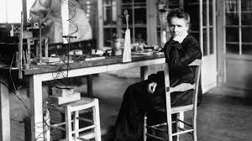
Edith Wharton  1862-1937  NOVELIST  Her gorgeous and keenly observed novels revealed to us much about what makes America tick. She examined women's roles, and exposed class conflict, gender wars, and social hypocrisy. Best of all, she gave us delicious reads. | 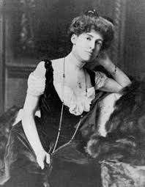
Mary Cassatt  1844-1926  ARTIST  Over the objections of her father and despite the initial disdain of male painters, she became an acclaimed chronicler of the tenderest moments in women's lives. | 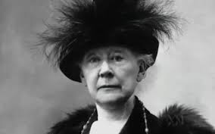
Harriet Tubman  1820-1913  ABOLITIONIST  A fugitive slave who, at great peril to herself, helped nearly 300 slaves escape the South via the Underground Railroad. She was also a Civil War spy and nurse, a promoter of education, and a campaigner for women's suffrage. | 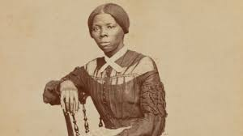
Carrie Chapman Catt  1859-1947  SUFFRAGIST  Her husband agreed she should devote four months a year to securing the vote for women. She packed a lot in: As president of the National American Woman Suffrage Association (a merger of Anthony's organization and a more moderate one), she led the strategic push to pass the 19th Amendment, which was ratified in August 1920. | 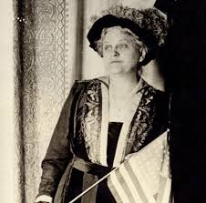
Edith Wharton  1862-1937  NOVELIST  Her gorgeous and keenly observed novels revealed to us much about what makes America tick. She examined women's roles, and exposed class conflict, gender wars, and social hypocrisy. Best of all, she gave us delicious reads. | 