10. Monopoly Monopoly or as it was originally called “The Landlord’s Game” was patented in 1904 by Elizabeth Magie. She wanted the game to accurately represent the present system of land-grabbing with its usual outcomes and consequences. This would include the successes and failures you’d experience in the real world. Maggie redrew the board multiple times until it came out just right. Now a man by the name of Charles Darrow ripped off the game and sold a version to the Parker Brothers. Darrow and the P.B. made millions. Maggie didn’t receive credit for two other games she invented, King’s Men and Bargain Day.
9. Fire Escape Anna Connelly invented a significantly upgraded version of the fire escape. Before her invention metal or rope ladders were used to escape a burning building. Her design was patented in 1887, during this period in time buildings had multiple floors, all of which were made of wood. Fire trucks at the time were a truck with a water cart attached, fire ladders only reached up to the 4th floor so if you lived higher than that you were out of luck if fire broke out. In 1979 New York City passed a law requiring all multi story buildings to have a fire escape. Since then the fire escape has saved hundreds of thousands of lives.
8. Kevlar Kevlar fiber was invented by Stephanie Kwolek in 1966. Now everyone knows Kevlar from Kevlar vests but it is actually used in over 200 other products. This is bound to happen though considering Kevlar is 5 times stronger than steel. Car and bicycle tires, underwater mooring lines, racing sails,modern drumheads, frying pans, running shoes, cables, audio equipment, brakes, and smartphone parts are just a few.
7. Submarine Telescope and Lamp Little is known about the inventor of the submarine telescope and lamp, Sarah Mather. She was granted a patent for her invention in 1845. The invention was primarily used to inspect ship hulls that were still in the water. Her invention was used in submarine warfare during the Civil War, as well as detecting Confederate underwater movement.
6. Life Raft Maria Beasley invented an upgraded, much improved version of the life raft. Before her invention, life rafts were essentially just a handful of boards connected, she changed the design to have fold out hand rails, metal floats and a design that unfolded much faster. In her patent it states her design as being fireproof which was possibly important as wooden rafts in a wooden ship caught on fire would possibly not even make it into the water to save anyone.
5. Invisible Glass Katharine Blodgett an American scientist invented invisible glass while working for GE or General Electric. She was the first women to receive a doctorate in physics from Cambridge University and the first female scientist toe be hired by GE.
4. Wireless Transmission Technology Hedy Lamarr an Austrian born actress, together with George Antheil, invented a system for radio controlled torpedoes during world War 2. This invention used spread spectrum and frequency hopping technology to remove the threat of jamming by Axis forces.This laid the groundwork for technology like gps, wifi and bluetooth.
3. Windshield Wipers March Anderson invented the windshield wipers in 1903 after a trip to New York City. She came up with a clever design to remove the rain or snow with was a swinging arm with a piece of rubber on the end that was attached to a level inside the car. People were skeptical at first of this design but by 1916 they had become standard on most vehicles. The next year Charlotte Bridgewood invented the automatic windshield wiper and the rest is history.
2. Paper Bag Margaret Knight invented the flat bottomed paper bag machine in 1868. Slightly modified and updated version is still used today to create grocery paper bags. A corrupt individual by the name of Charles Annan tried to steal her design claiming a women could never invent such an innovative machine,
1. Computer Language Compiler Grace Hopper along with Howard Aiken designed a full room sized computer for Harvard called the Mark 1 in 1944. In 1952 Hopper and her team invented the first compiler that translated written instructions into a code that could be read and processed by a computer. Later this became the foundation for one of the big programming languages COBOL.
https://www.youtube.com/watch?v=rPDf9H-8bRc
https://www.youtube.com/watch?v=rPDf9H-8bRc

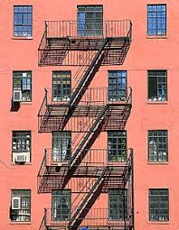  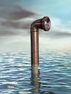  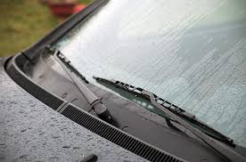  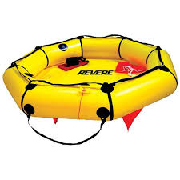  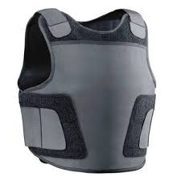  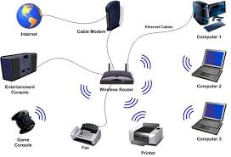  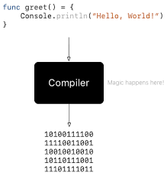  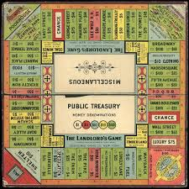 | 10. Monopoly: Monopoly or as it was originally called “_________________________” was patented in 1904 by Elizabeth Magie. She wanted the game to accurately represent the present system of land-grabbing with its usual ___________________ and ____________________. This would include the successes and failures you’d experience in the real world. Maggie redrew the board multiple times until it came out just right. Now a man by the name of Charles Darrow __________________________ the game and sold a version to the Parker Brothers. Darrow and the P.B. made millions. Maggie didn’t receive credit for two other games she invented, King’s Men and Bargain Day.  9. Fire Escape: Anna Connelly invented a significantly upgraded version of the fire escape. Before her invention metal or rope ___________________ were used to escape a burning building. Her design was patented in 1887, during this period in time buildings had multiple floors, all of which were made of wood. Fire trucks at the time were a truck with a water cart attached, fire ladders only reached up to the __________________ so if you lived higher than that you were out of luck if fire broke out. In 1979 New York City passed a law requiring all multi story buildings to have a fire escape. Since then the fire escape has saved hundreds of thousands of lives.  8. Kevlar: Kevlar _______________ was invented by Stephanie Kwolek in 1966. Now everyone knows Kevlar from Kevlar vests but it is actually used in over 200 other products. This is bound to happen though considering Kevlar is __________________ stronger than steel. Car and bicycle tires, underwater mooring lines, racing sails, modern drumheads, frying pans, running shoes, cables, audio equipment, brakes, and smartphone parts are just a few.  7. Submarine Telescope and Lamp: Little is known about the inventor of the submarine telescope and lamp, Sarah Mather. She was granted a patent for her invention in 1845. The invention was primarily used to inspect ___________________ that were still in the water. Her invention was used in submarine warfare during the Civil War, as well as detecting Confederate underwater movement.  6. Life Raft: Maria Beasley invented an upgraded, much improved version of the life raft. Before her invention, life rafts were essentially just a handful of __________________ connected, she changed the design to have fold out hand rails, metal floats and a design that unfolded much faster. In her patent it states her design as being _________________ which was possibly important as wooden rafts in a wooden ship caught on fire would possibly not even make it into the water to save anyone.  5. Invisible Glass: Katharine Blodgett an American scientist invented invisible glass while working for GE or General Electric. She was the first women to receive a __________________ in physics from ___________________ University and the first female scientist toe be hired by GE.  4. Wireless Transmission: Technology Hedy Lamarr an Austrian born ____________________, together with George Antheil, invented a system for radio controlled ___________________ during world War 2. This invention used spread spectrum and frequency hopping technology to remove the threat of jamming by Axis forces. This laid the groundwork for technology like gps, wifi and bluetooth.  3. Windshield Wipers: March Anderson invented the windshield wipers in 1903 after a trip to New York City. She came up with a clever design to remove the rain or snow with was a ___________________ arm with a piece of rubber on the end that was attached to a level inside the car. People were skeptical at first of this design but by 1916 they had become standard on most __________________. The next year Charlotte Bridgewood invented the automatic windshield wiper and the rest is history.  2. Paper Bag: Margaret Knight invented the flat bottomed paper bag machine in 1868. Slightly modified and updated version is still used today to create _________________ paper bags. A corrupt individual by the name of Charles Annan tried to steal her design claiming a women could never invent such an innovative machine.  1. Computer Language Compiler: Grace Hopper along with Howard Aiken designed a full room sized computer for ________________________ called the __________________ in 1944. In 1952 Hopper and her team invented the first compiler that translated written instructions into a code that could be read and processed by a computer. Later this became the foundation for one of the big programming languages COBOL.

