Who Was Vincent Van Gogh?

Family
Vincent van Gogh was born in 1853 in Netherlands. He was a post-impressionist painter whose work highly influenced 20th-century art.

Vincent van Gogh’s father was a minister, and his mother was an artist whose love of nature, drawing and watercolours was transferred to her son. Van Gogh was born exactly one year after his parents' first son, also named Vincent, was stillborn. The eldest of six living children, van Gogh had two younger brothers and three younger sisters.

Work in different cities and countries
At age 15, van Gogh's family was struggling financially, and he was forced to leave school and go to work. He got a job at his uncle's art dealership in The Hague. By this time, van Gogh was fluent in French, German and English, as well as his native Dutch.
In June of 1873, van Gogh was transferred to a Gallery in London. There, he fell in love with English culture, especially Charles Dickens.

Studying to become a preacher
Van Gogh then taught in a Methodist boys' school, and also preached. Although raised in a religious family, it wasn't until this time that he seriously began to consider devoting his life to the church. Hoping to become a minister, he prepared to take the entrance exam to the School of Theology in Amsterdam. After a year of studying diligently, he refused to take the Latin exams, calling Latin a "dead language" of poor people, and was denied entrance.

Preacher career
The same thing happened at the Church of Belgium: in the winter of 1878, van Gogh volunteered to move to a coal mine in Belgium, a place where preachers were usually sent as punishment. He preached to the sick, and drew pictures of the miners and their families, who called him "Christ of the Coal Mines." The church committees were not as pleased. They disagreed with van Gogh's lifestyle, so they refused to renew van Gogh's contract, and he was forced to find another occupation.

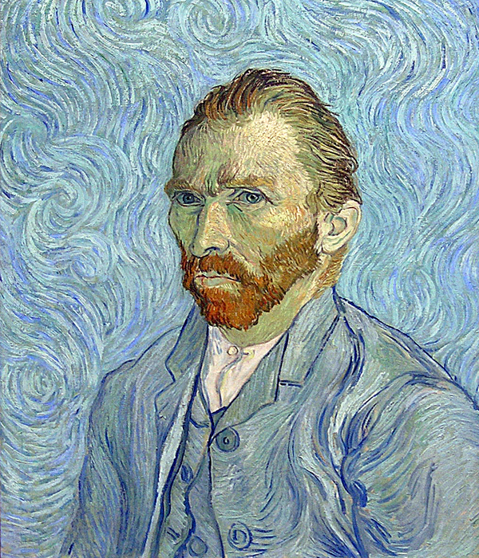

Van Gogh’s Paintings and Artwork

Brussels, Paris and Arles
In the fall of 1880, van Gogh decided to move to Brussels and become an artist. Though he had no formal art training, his (favourite) brother Theo offered to support van Gogh financially. He began taking lessons on his own, studying from books.

In Paris, van Gogh first saw impressionist art, and he was inspired by the colour and light. He began studying with Henri de Toulouse-Lautrec, Camille Pissarro and others. To save money, he and his friends posed for each other instead of hiring models. Van Gogh was passionate, and he argued with other painters about their works, alienating those who became tired of his bickering.

When Van Gogh lived in Paris, he became influenced by Japanese art and began studying eastern philosophy to enhance his art and life. He dreamed of traveling to Japan, but was told by Toulouse-Lautrec that the light in the village of Arles was just like the light in Japan. In February 1888, van Gogh boarded a train to the south of France. He moved into the "yellow house" and spent his money on paint rather than food.

Vincent van Gogh completed more than 2,100 works: oil paintings and watercolours, drawings and sketches. A few of van Gogh’s most well-known artworks include:

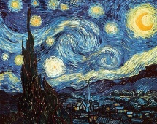
'The Starry Night'
Van Gogh painted "The Starry Night" in the asylum one year before his death.

'Sunflowers'
Van Gogh painted two series of yellow sunflowers in a vase.

'Self-Portraits'
Over the course of 10 years, van Gogh created more than 43 self-portraits as both paintings and drawings. "People say, and I am willing to believe it, that it is hard to know yourself. But it is not easy to paint yourself, either.”

Van Gogh Museum
In 1973, the Van Gogh Museum opened its doors in Amsterdam to make the works of Vincent van Gogh accessible to the public. The museum houses more than 200 van Gogh paintings, 500 drawings and 750 written documents including letters to Vincent’s brother Theo.

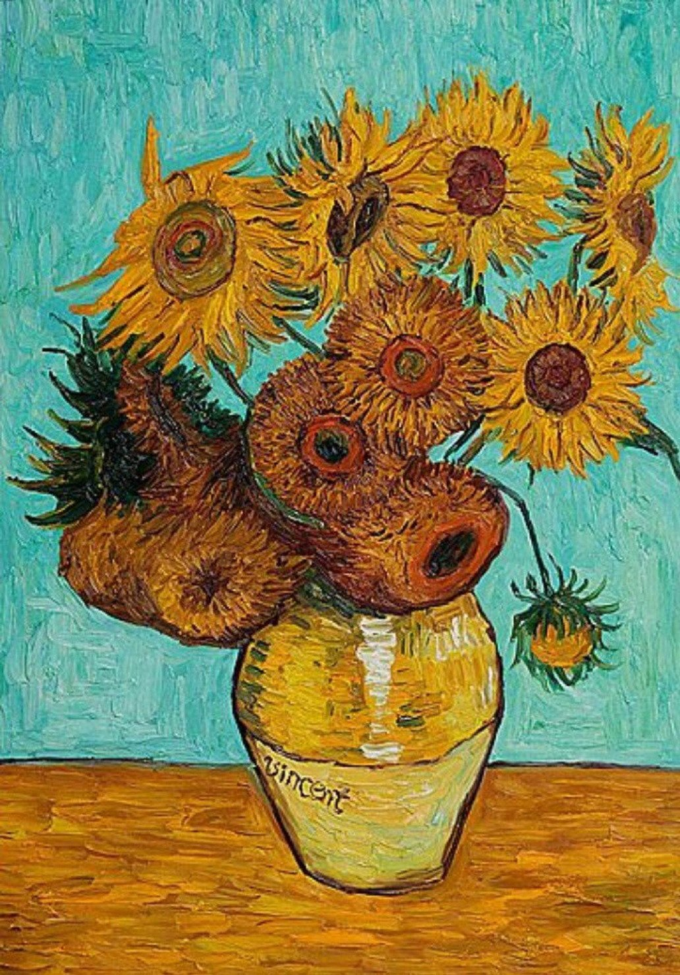

Off with his Ear, Asylum & End of Life

Why Did Van Gogh Cut Off His Ear?
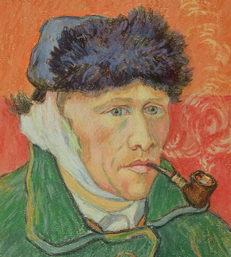
In December 1888, van Gogh was living on coffee, bread and absinthe in France, and he found himself feeling sick and strange and his psychological health was declining. Around this time, he is known to have eaten paint.

His brother Theo was worried, and he offered Paul Gauguin money to go watch over Vincent in Arles. Within a month, van Gogh and Gauguin were arguing constantly, and one night, Gauguin walked out. Van Gogh followed him, and when Gauguin turned around, he saw van Gogh holding a razor in his hand. Hours later, van Gogh went to the local brothel and paid for a prostitute. With blood pouring from his hand, he offered her his ear (a portion of his lobe), asking her to "keep this object carefully."

The police found van Gogh in his room the next morning, and admitted him to a hospital. Theo arrived on Christmas Day to see van Gogh, who was weak from blood loss and having violent seizures, but he got better was released only two weeks later.

Asylum
Vincent was alone and depressed. For hope, he turned to painting and nature, but could not find peace and was hospitalized again. He would paint at the yellow house during the day and return to the hospital at night. Van Gogh decided to move to the asylum after the people of Arles signed a petition saying that he was dangerous. He began painting in the hospital gardens. Van Gogh was worried about his future in 1890 a lot because his brother Theo told him to be more careful with his finances. Van Gogh thought Theo was no longer interested in selling his art.
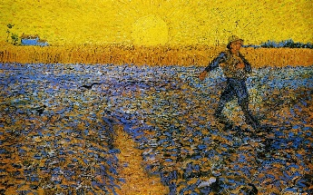

Death
On July 27, 1890, Vincent van Gogh went out to paint in the morning carrying a loaded pistol and shot himself in the chest, but the bullet did not kill him. He was found bleeding in his room.

Van Gogh was taken to a nearby hospital and his doctors sent for Theo, who arrived to find his brother sitting up in bed and smoking a pipe. They spent the next couple of days talking together, and then van Gogh asked Theo to take him home. On July 29, 1890, Vincent van Gogh died in the arms of his brother. He was 37 years old.

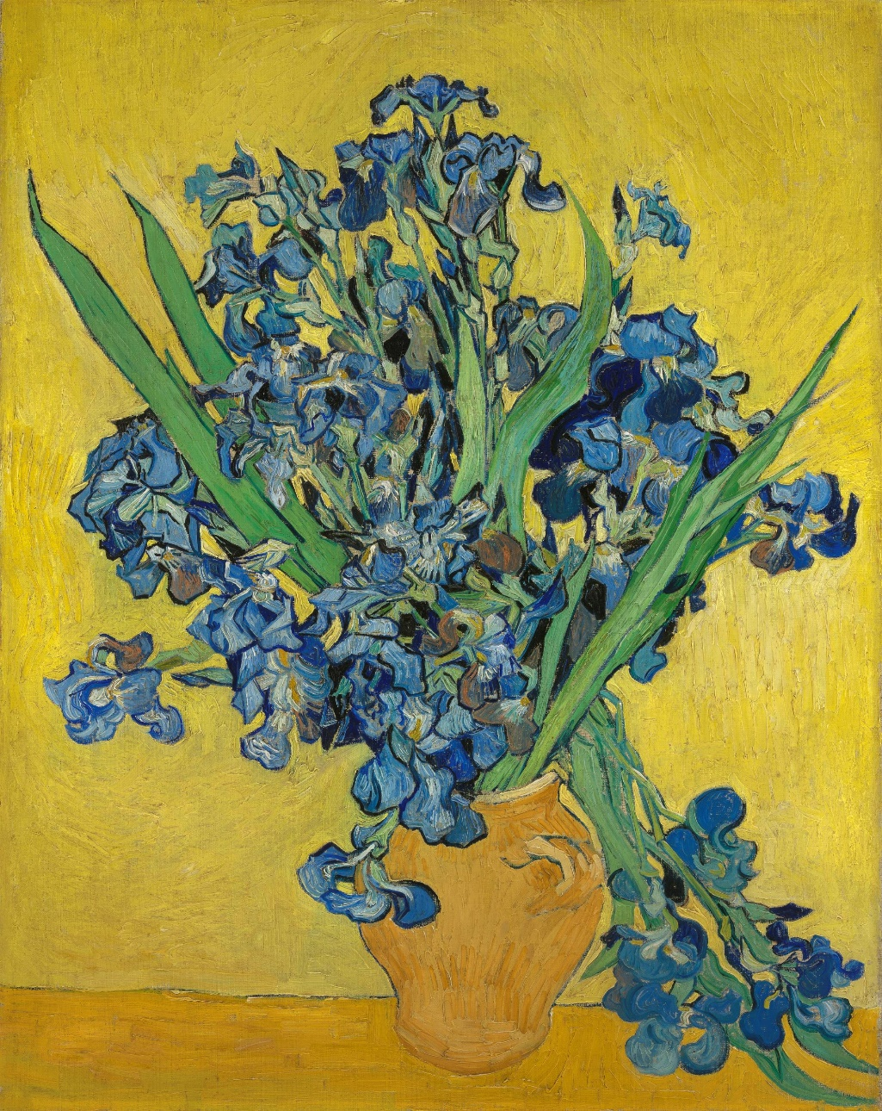

Van Gogh’s Love Life and Personal Relationships

Love life
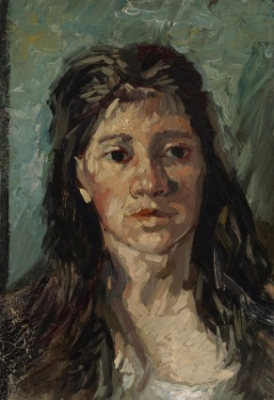
Van Gogh had a catastrophic love life. He was attracted to women in trouble, thinking he could help them. When he fell in love with his recently widowed cousin, Kate, she was repulsed and fled to her home in Amsterdam.

Van Gogh then moved to The Hague and fell in love with Clasina Hoornik, an alcoholic prostitute. She became his companion, mistress and model. When Hoornik went back to prostitution, van Gogh became utterly depressed. In 1882, his family threatened to cut off his money unless he left Hoornik and The Hague.

When he was working in London, he fell in love with his landlady's daughter, Eugenie Loyer. When she rejected his marriage proposal, van Gogh suffered a breakdown. He threw away all his books except for the Bible, and devoted his life to God. He became angry with people at work, telling customers not to buy the "worthless art," and was eventually fired.
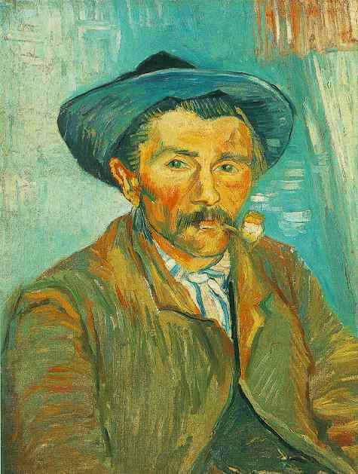
Theo and Johanna
On January 31, 1890, Vincent’s brother Theo and his wife, Johanna, gave birth to a boy and named him Vincent. Around this time, Theo sold van Gogh's "The Red Vineyards" painting for 400 francs.

Theo, who was suffering from syphilis and weakened by his brother's death, died six months after his brother. He was buried in Utrecht, but in 1914 Theo's wife, Johanna, who was a dedicated supporter of van Gogh's works, had Theo's body reburied in the Auvers cemetery next to Vincent.

Theo's wife Johanna then collected as many of van Gogh's paintings as she could, but discovered that many had been destroyed or lost, van Gogh's own mother having thrown away crates full of his art.

On March 17, 1901, 71 of van Gogh's paintings were displayed at a show in Paris, and his fame subsequently grew enormously. His mother lived long enough to see her son celebrated as an artist and a genius. Today, Vincent van Gogh is considered the greatest Dutch painter after Rembrandt.

