Cleopatra VII, Queen (c. 69 BCE–30 BCE)
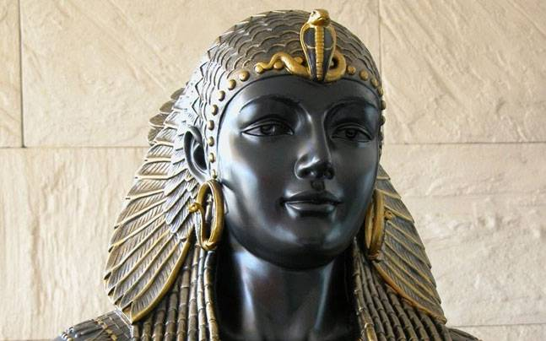
Cleopatra, who reigned as queen of Egypt during the 1st century B.C., is one of the most famous female rulers in history.

Who Was Cleopatra?
Cleopatra VII was part of the Macedonian dynasty that took over rule of Egypt. During her reign, she forged political alliances and became romantically involved with Roman military leaders Julius Caesar and Mark Antony. One of antiquity's most famous rulers, Cleopatra's life inspired William Shakespeare's play Antony and Cleopatra and numerous film dramatizations, most famously a 1963 feature starring Elizabeth Taylor.

How did Cleopatra Die?
After suffering a crushing defeat at the hands of Roman rival Octavian, Mark Antony, believing Cleopatra to be dead, killed himself. Cleopatra followed by also committing suicide, supposedly by being bitten by an asp, although the truth is unknown. After her death on August 12, 30 B.C., Cleopatra was buried alongside Antony in a yet to be discovered location.

Cleopatra's Children
In 47 B.C., Cleopatra bore Julius Caesar a son, whom she named Caesarion. Later, she had three children with Antony: twins Alexander Helios and Cleopatra Selene and another son, Ptolemy Philadelphus.

Queen of Egypt
In 51 B.C., Ptolemy XII died, leaving the throne to 18-year-old Cleopatra and her brother, the 10-year-old Ptolemy XIII. It is likely that the two siblings married, as was customary at the time.

Cleopatra and Caesar
Around this same time, the civil war between military leaders Julius Caesar and Pompey was consuming Rome. Pompey eventually sought refuge in Egypt, but, on orders by Ptolemy, was killed. In pursuit of his rival, Caesar followed Pompey into Egypt, where he met and eventually fell in love with Cleopatra. In Caesar, Cleopatra now had access to enough military muscle to dethrone her brother and solidify her grip on Egypt as sole ruler. Caesar restored Cleopatra to the throne. Cleopatra eventually followed Caesar back to Rome, but returned to Egypt, following his assassination.

Cleopatra and Mark Antony
In 41 B.C., Marc Antony, part of the Second Triumvirate that ruled Rome following the murder of Caesar, sent for Cleopatra so that she could answer questions about her allegiance to the empire's fallen leader. Cleopatra agreed to his request and made a lavish entrance into the city of Tarsus. Captivated by her beauty and personality, Antony plunged into a love affair with Cleopatra.
Like Caesar before him, Antony was embroiled in a battle over Rome's control. His rival was Caesar's own great-nephew, Gaius Octavius, also known as Octavian (and later as Emperor Caesar Augustus).
Antony, who presided over Rome's eastern areas, saw in Cleopatra the chance for financial and military support to secure his own rule over the empire. Cleopatra had her own motivations, as well: In exchange for her help, she sought the return of Egypt's eastern empire, which included large areas of Lebanon and Syria.

Defeat by Octavian
In 31 B.C., Cleopatra and Antony combined armies to try to defeat Octavian in a raging sea battle at Actium, off Greece’s west coast. The clash, however, proved to be a costly defeat for the Egyptians, forcing Antony and Cleopatra to flee back to Egypt.
Following Cleopatra's death, Egypt became a province of the Roman Empire.

Princess Diana - Mini Biography

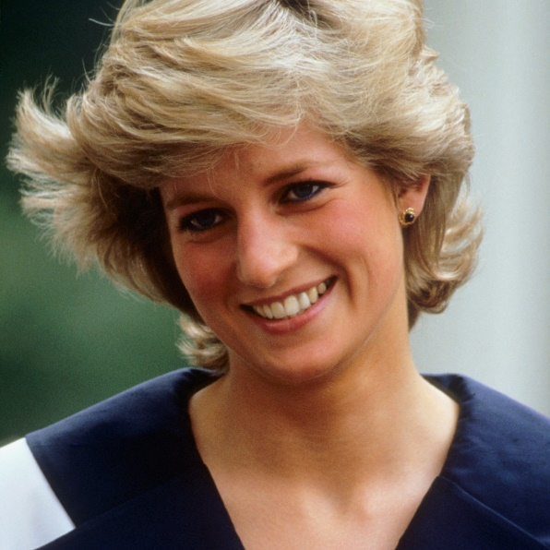
Who Was Princess Diana?
Born Diana Spencer in 1961, Princess Diana became Lady Diana Spencer. She married the heir to the British throne, Prince Charles in 1981. They had two sons and later divorced in 1996. Diana died on August 31, 1997, from injuries she sustained in a car crash in Paris. She is remembered as the "People's Princess" because of her widespread popularity and global humanitarian efforts.

Young Princess Diana
Her parents divorced when Diana was young, and her father won custody of the children. Although she was known for her shyness while growing up, she did show an interest in music and dancing. Diana also had a great fondness for children. After attending finishing school in Switzerland, she moved to London and began working with children.

Wedding
Diana was no stranger to the British royal family, having played with Prince Andrew and Prince Edward as a child at an estate owned by Queen Elizabeth II. In 1977, she became reacquainted with their older brother, Prince Charles, who was 13 years her senior. As the heir to the British throne, Prince Charles was usually the subject of media attention, and his courtship of Diana was no exception. The press and the public were fascinated by this seemingly odd couple—the reserved, garden-loving prince and the shy young woman with an interest in fashion and popular culture. When the couple married in 1981, the ceremony was broadcast on television around the world, with millions of people tuning in to see what many considered to be the wedding of the century.

Family Life and Divorce
On June 21, 1982, Diana and Charles had their first child: Prince William Arthur Philip Louis. He was joined by a brother, Prince Henry Charles Albert David—known widely as "Prince Harry. Initially overwhelmed by her royal duties and the intense media coverage of nearly every aspect of her life, she began to develop and pursue her own interests. Diana served as a strong supporter of many charities and worked to help the homeless, people living with HIV and AIDS and children in need.
The couple became estranged over the years, and there were reports of infidelities from both parties. During their union, Diana struggled with depression and bulimia. The divorce was finalized in 1996.

Princess Diana: Death
Even after the divorce, Diana maintained a high level of popularity. She devoted herself to her sons and to such charitable efforts as raising awareness about the dangers of leftover land mines in war-torn Angola. She also continued to experience the negative aspects of fame, whipping the British tabloids into a frenzy when she began dating Egyptian film producer and playboy Dodi Fayed in 1997.
While visiting Paris, the couple was involved in a car crash after trying to escape from the paparazzi early in the morning of August 31, 1997. Fayed and the driver were pronounced dead at the scene; Diana initially survived the crash, but succumbed to her injuries at a Paris hospital a few hours later.
Queen Elizabeth II, who was criticized for not immediately responding publicly to Diana’s death, made a televised address from Buckingham Palace on September 5, in which she said: “No one who knew Diana will ever forget her. Millions of others who never met her, but felt they knew her, will remember her. I, for one, believe there are lessons to be drawn from her life and from the extraordinary and moving reaction to her death. I share in your determination to cherish her memory.”

Controversy and Legacy
Following an investigation into the fatal accident, a report released in 1999 determined that the driver was at fault for driving at a high speed while under the influence of alcohol and anti-depressant drugs.
Despite the report, rumors persisted for years about alternative reasons for the accident. One conspiracy theory held that it was part of an assassination arranged by the royal family, although no additional evidence emerged to support that theory.
Prince William and his wife Kate Middleton also remembered Diana when naming their second child, Princess Charlotte Elizabeth Diana.

Malala Yousafzai

Children's Activist, Women's Rights Activist, Activist (1997–)

Malala Yousafzai Facts
Malala Yousafzai is a Pakistani education advocate who, at the age of 17, became the youngest person to win the Nobel Peace Prize after surviving an assassination attempt by the Taliban. Born on July 12, 1997, Yousafzai became an advocate for girls' education when she herself was still a child, which resulted in the Taliban issuing a death threat against her. On October 9, 2012, a gunman shot Malala when she was traveling home from school. She survived and has continued to speak out on the importance of education.

Malala Yousafzai: Speech at the U.N.
Nine months after being shot by the Taliban, Malala Yousafzai gave a speech at the United Nations on her 16th birthday in 2013. Yousafzai highlighted her focus on education and women's rights, urging world leaders to change their policies. She also urged action against illiteracy, poverty and terrorism:
“The extremists were, and they are, afraid of books and pens. The power of education frightens them. They are afraid of women... Let us pick up our books and pens. They are our most powerful weapons.” At Malala Yousafzai’s 2013 speech, Secretary-General Ban Ki-moon pronounced July 12th – Yousafzai's birthday – 'Malala Day' in honor of the young leader’s activism to ensure education for all children.

Early Life and Family
Malala Yousafzai was born in Mingora, Pakistan, located in the country's Swat Valley, on July 12, 1997. For the first few years of her life, her hometown remained a popular tourist spot that was known for its summer festivals. However, the area began to change as the Taliban tried to take control.

Education Activist
Yousafzai attended a school that her father had founded. After the Taliban began attacking girls' schools, Malala gave a speech in Peshawar, Pakistan, in September 2008. The title of her talk was, "How dare the Taliban take away my basic right to education?"
With a growing public platform, Yousafzai continued to speak out about her right, and the right of all women, to an education. Her activism resulted in a nomination for the International Children's Peace Prize in 2011. That same year, she was awarded Pakistan's National Youth Peace Prize.
Malala and her family learned that the Taliban had issued a death threat against her because of her activism, although she and her family initially felt that the fundamentalist group would not actually harm a child.

Shot by the Taliban
In 2012, when Malala was riding a bus with friends on their way home from school, a masked gunman boarded the bus and demanded to know which girl was Malala. The gunman fired at her, hitting Malala in the left side of her head; the bullet then traveled down her neck. A portion of her skull was removed to treat her swelling brain. To receive further care, she was transferred to Birmingham, England. Two other girls were also injured in the attack.
The shooting resulted in a massive outpouring of support for Yousafzai, which continued during her recovery. Unfortunately, the Taliban still considers Yousafzai a target, although Yousafzai remains a staunch advocate for the power of education.

Oxford University
Malala Yousafzai tweeted in August 2017 that she was accepted to Oxford University, where she will study philosophy, politics and economics. For her 18th birthday she opened a school for Syrian refugee girls in Lebanon.
That day, she also wrote on The Malala Fund website: “The shocking truth is that world leaders have the money to fully fund primary AND secondary education around the world - but they are choosing to spend it on other things, like their military budgets. In fact, if the whole world stopped spending money on the military for just 8 days, we could have the $39 billion still needed to provide 12 years of free, quality education to every child on the planet.”

Grace Hopper Biography

Mathematician, Military Leader, Computer Programmer (1906–1992)
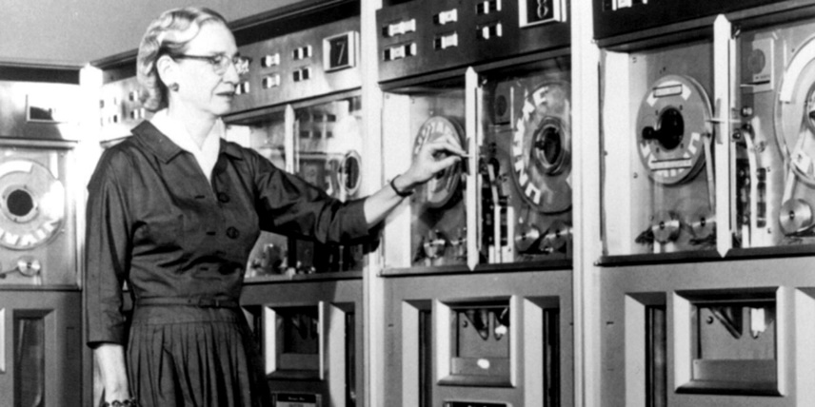

Synopsis
Born in New York City in 1906, Grace Hopper joined the U.S. Navy during World War II and was assigned to program the Mark I computer. She continued to work in computing after the war, leading the team that created the first computer language compiler, which led to the popular COBOL language. She resumed active naval service at the age of 60, becoming a rear admiral before retiring in 1986. Hopper died in Virginia in 1992.

Early Life
Born Grace Brewster Murray in New York City in 1906, Grace Hopper studied math and physics at Vassar College. After graduating from Vassar in 1928, she proceeded to Yale University, where, in 1930, she received a master's degree in mathematics. That same year, she married Vincent Foster Hopper, becoming Grace Hopper (a name that she kept even after the couple's 1945 divorce). Starting in 1931, Hopper began teaching at Vassar while also continuing to study at Yale, where she earned a Ph.D. in mathematics in 1934—becoming one of the first few woman to earn such a degree.

World War II
Hopper, who became an associate professor at Vassar, continued to teach until World War II compelled her to join the U.S. Naval Reserve in December 1943 (she opted for the Navy, as it had been her grandfather's branch of service). She was commissioned as a lieutenant in June 1944. Given her mathematical background, Hopper was assigned to the Bureau of Ordnance Computation Project at Harvard University, where she learned to program a Mark I computer.

Career in Computing
As a research fellow at Harvard, she worked with the Mark II and Mark III computers. She was at Harvard when a moth was found to have shorted out the Mark II, and is sometimes given credit for the invention of the term "computer bug"—though she didn't actually author the term, she did help popularize it.

Wanting to continue to work with computers, Hopper moved into private industry where she oversaw programming for the UNIVAC computer. In 1952, her team created the first compiler for computer languages a precursor for the Common Business Oriented Language, or COBOL, a widely adapted language that would be used around the world.

Later Years and Legacy
In 2004, the University of Missouri has honored Hopper with a computer museum on their campus, dubbed “Grace’s Place.” On display are early computers and computer components to educator visitors on the evolution of the technology.
In addition to her programming accomplishments, Hopper's legacy includes encouraging young people to learn how to program. The Grace Hopper Celebration of Women In Computing Conference is a technical conference that encourages women to become part of the world of computing, while the Association for Computing Machinery offers a Grace Murray Hopper Award.

Additionally, on her birthday in 2013, Hopper was remembered with a "Google Doodle."

Billie Jean King Biography
Athlete, Tennis Player (1943–)

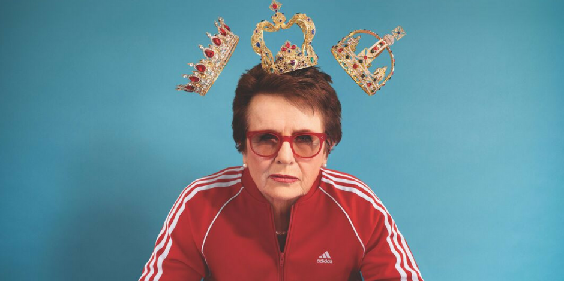
Who Is Billie Jean King?
Born on November 22, 1943, in Long Beach, California, Billie Jean King became the top-ranked women's tennis player by 1967. In 1973, she formed the Women's Tennis Association and famously defeated Bobby Riggs in the "Battle of the Sexes."

Billie Jean King vs. Bobby Riggs
For all her tennis accomplishments, Billie Jean King is probably best known for her 1973 match against former men's champion Bobby Riggs, dubbed the "Battle of the Sexes." The 55-year-old Riggs had assumed a chauvinistic public persona to bait the sport’s top women into playing him.
The match took place on September 20, 1973, at the Houston Astrodome. Embracing the spectacle of the event, King entered the court on a gold throne carried by four muscular men, while Riggs rolled in on a rickshaw pulled by a team of women called "Bobby's Bosom Buddies." But King was all business once the match started, and she handily beat Riggs in straight sets before an estimated television audience of 90 million viewers. Afterward, King acknowledged the pressure she felt that day. "I thought it would set us back 50 years if I didn't win that match," she said. "It would ruin the women's tour and affect all women's self esteem."

'Battle of the Sexes' Movie
The story of the 1973 King-Riggs match spawned the 2017 feature film Battle of the Sexes, starring Emma Stone as King and Steve Carell as Riggs. The film drew generally strong reviews, with both Stone and Carell earning Golden Globe nominations for their performances.

Major Singles Titles and Rise to No. 1
In 1968, having claimed the world's No. 1 ranking in women's tennis, King turned professional.
Renowned for her speed, net game and backhand shot, King was a regular presence in the winner's circle in singles, doubles and mixed-doubles tournaments over the next few years. In 1972, she won the U.S. Open, French Open and Wimbledon to claim three Grand Slam titles in one year. Altogether, King won 39 major singles, doubles and mixed-doubles championships, including a record 20 at Wimbledon.

Equal Pay Activism, WTA and WTT
Never shy about speaking her mind, she advocated for equal payouts to both genders. In 1970, she joined the brand-new Virginia Slims Tour for women, and in 1971, she became the first female athlete to top $100,000 in prize money in a single year.
In 1973, she threatened a boycott of the U.S. Open if the pay inequality was not addressed. Her demands met, the U.S. Open became the first major tournament to offer equal prize money to women and men.

Acknowledging Her Sexuality
The budding tennis star married Larry King in 1965, but soon found herself wrestling with her feelings for other women. The first prominent woman athlete to admit her homosexuality, King became a torchbearer for the LGBT community. She divorced her husband in 1987, and settled into a long-term relationship with former player Ilana Kloss.

Tennis and LGBT Ambassador
Named to the International Tennis Hall of Fame in 1987, King remained closely tied to the sport throughout the 1990s as a television commentator. She also served as captain of the U.S. team at the 1996 and 2000 Summer Olympics. In 2006, the New York City facility that hosts the U.S. Open was renamed the USTA Billie Jean King National Tennis Center in her honor.

Hedy Lamarr Biography

Inventor, Film Actress, Classic Pin-Ups (1913–2000)

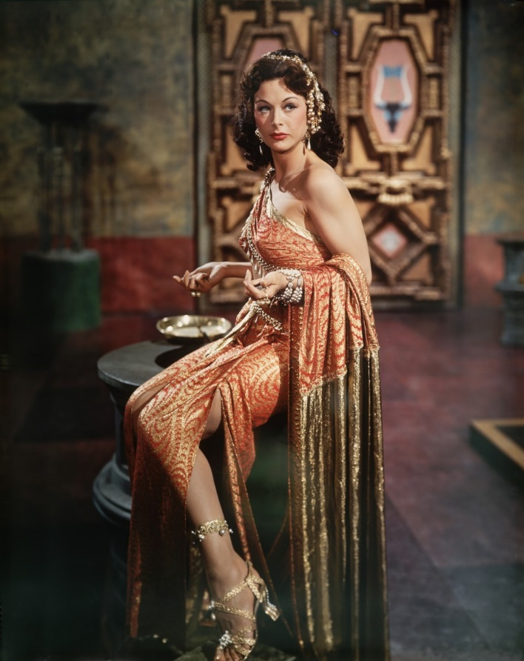
Who Was Hedy Lamarr?
Hedy Lamarr was an actress during MGM's "Golden Age." She starred in such films as Tortilla Flat, Lady of the Tropics, Boom Town and Samson and Delilah, with the likes of Clark Gable and Spencer Tracey.
Lamarr was also a scientist, co-inventing an early technique for spread spectrum communications—key to many wireless communications of our present day.

Hollywood Career
Actress Hedy Lamarr was born Hedwig Eva Maria Kiesler on November 9, 1913, in Vienna, Austria. Discovered by an Austrian film director as a teenager, she gained international notice in 1933, with her role in the sexually charged Czech film Ecstasy. After her unhappy marriage ended with Fritz Mandl, a wealthy Austrian munitions manufacturer who sold arms to the Nazis, she fled to the United States and signed a contract with the Metro-Goldwyn-Mayer studio in Hollywood under the name Hedy Lamarr.

Often referred to as one of the most gorgeous and exotic of Hollywood's leading ladies, Lamarr made a number of well-received films during the 1930s and 1940s. She was reportedly producer Hal Wallis's first choice for the heroine in his classic 1943 film, Casablanca, a part that eventually went to Ingrid Bergman.

'Secret Communications System'
In 1942, during the heyday of her career, Lamarr earned recognition in a field quite different from entertainment. She and her friend, the composer George Antheil, received a patent for an idea of a radio signaling device, or "Secret Communications System," which was a means of changing radio frequencies to keep enemies from decoding messages.
Originally designed to defeat the German Nazis, the system became an important step in the development of technology to maintain the security of both military communications and cellular phones.
Lamarr wasn't instantly recognized for her communications invention since its wide ranging impact wasn't understood until decades later.
However, in 1997 Lamarr and Antheil were honored with the Electronic Frontier Foundation (EFF) Pioneer Award, and that same year Lamarr became the first female to receive the BULBIE™ Gnass Spirit of Achievement Award, considered the "Oscars" of inventing.

Personal Life, Death and Legacy
Lamarr was married six times. In 1953, Lamarr completed the naturalization process and became a U.S. citizen. In her later years, Lamarr lived a reclusive life in Casselberry, a community just north of Orlando, Florida, where she died on January 19, 2000, at the age of 86.

