List of songs:
Artist 1 | Artist 2
1 | 1
2 | 2
3 | 3
4 | 4

Artist 1 Tom Jones | Artist 2 Elvis Presley
1 It’s not unusual | 1 Suspicious minds
2 Delilah | 2 Jailhouse Rock
3 She’s a lady | 3 Always on my mind
4 Sexbomb | 4 Little less conversation

Artist 1 | Artist 2

Artist 1 | Artist 2

Artist 1 | Artist 2

Biography in Short
Tom Jones is a Welsh rock, pop and soul singing legend best known as an international hit maker over the last five decades. His popular singles include "It's Not Unusual," "Green Green Grass of Home," "Delilah," "Till" and "A Boy From Nowhere."

Tom Jones was born on June 7, 1940, in Pontypridd, Wales. Influenced as a child by American blues, r&b and rock 'n' roll, over the past five decades the singing legend has produced hits in both the United States and the United Kingdom.
He continued to put forth successful albums from the '80s into the new millennium, with hits particularly catered to the British and European markets. Drawing on his extensive musical experience, Jones became a judge on the U.K. reality show The Voice in 2012.
Born Thomas John Woodward, Jones was the son of Thomas Woodward, a miner, and Freda Jones, a homemaker. From an early age Jones loved to sing at gatherings and in the school choir.
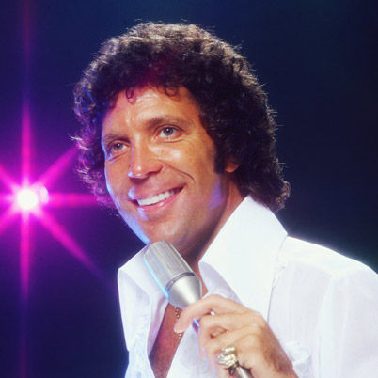

School and teenage years
As a child in school, he struggled with dyslexia but enjoyed listening to music, including BBC radio, which featured American blues, r&b and rock—genres which later influenced his musical style. He was also diagnosed with tuberculosis at the age of 12 and was kept quarantined at home for an extensive period of time.
As a teen, Jones was more interested in booze and girls rather than his education, and quit school at age 16. To earn money, he worked as a builder's laborer and a door-to-door vacuum salesman.
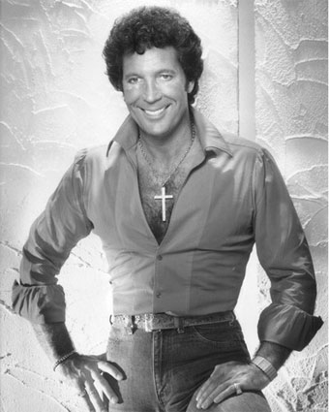

Career until 1980
In 1963, Jones started to sing with the band Tommy Scott with the Senators.
With a new solo career, the artist changed his name to Tom Jones. Decca Records signed Jones, but his first single, "Chills and Fever," didn't catch on. However, his second single, the groovy, carefree "It's Not Unusual," peaked at No. 1 on the British charts in 1965 and was an American top 10 hit.
With success came a U.S. appearance on The Ed Sullivan Show. Throughout the latter half of the 1960s, Jones had an array of hit singles, including "Once Upon a Time," "With These Hands," "Green, Green Grass of Home" (a no. 1 hit in the U.K.), "Detroit City," "I'll Never Fall in Love," "I'm Coming Home," "Delilah" and "Help Yourself."
From 1969 to 1971, Jones starred in his own TV show, This Is Tom Jones, which was based in America and aired in both the U.S. and Great Britain. He also released one of his most iconic hits, 1971's "She's a Lady," a track which reached no. 2 on the American charts though lyrically out of step with the feminist movement.
Jones spent much of the 1970s setting up shop in Las Vegas, hanging out with Elvis Presley, touring and launching a record label, MAM Records, with his manager.
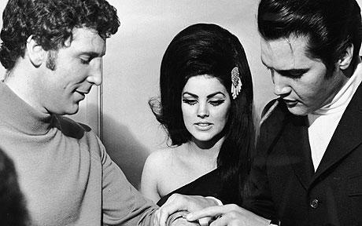

Later Career
Jones subsequently released the albums The Lead and How to Swing It (1994) and Reload (1999); the latter was a collection of covers which went platinum six times in the United Kingdom and became a big seller internationally, offering up hits like "Mama Told Me Not to Come Home" and "Sex Bomb."
He also branched into TV and film, appearing as himself on The Simpsons, hosting award shows and acting in the films Mars Attacks! (1996) and Agnes Browne (1999).
Success continued through the 2000s, during which time he won the Brit Award for Best Male Artist. Other highlights included a performance for President Bill Clinton at the White House Millennium Celebration and for Britain’s monarchy for the Queen’s Golden Jubilee. Jones also received the Brit Award for Outstanding Contribution to Music.
In 2015, he released his 41st studio album Long Lost Suitcase to generally positive reviews. That same year, he published his memoir, Over the Top and Back: The Autobiography.
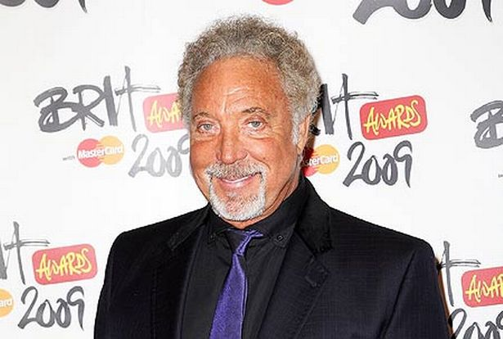

Personal Life
Jones married his childhood love Melinda "Linda" Trenchard in 1957 at age 16, and together they had a son, Mark, born the same year. They remained together for nearly 60 years until Trenchard died from cancer in 2016.
In 1974 Jones moved his family to the United States due to resentment of Britain's high taxes. He bought Dean Martin's house in California's posh Bel-Air area.
Though he remained married to Trenchard, Jones was well known for his infidelities. During his career heyday he admitted to sleeping with more than 250 groupies a year.
In 1987, he fathered a son through a four-day fling with model Katherine Berkery. Though for over 20 years Jones denied paternity, a DNA test in 2008 proved he was the boy's father.
For his musical accomplishments, Queen Elizabeth II bestowed upon Jones the honor of Order of the British Empire (OBE) in 1999 and knighted him in 2006.
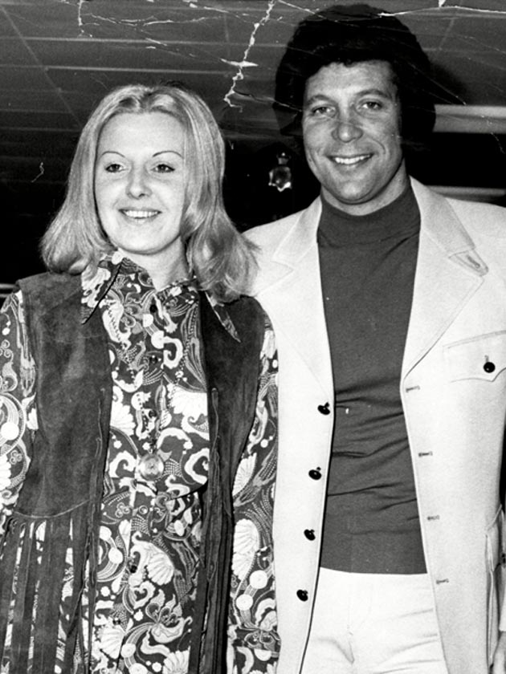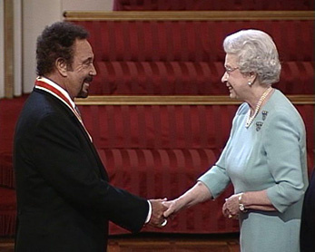
Short biography
Born on January 8, 1935, in Tupelo, Mississippi, Elvis Aron Presley came from very humble beginnings and grew up to become one of the biggest names in rock 'n' roll.
On August 16, 1977, at age 42, he died of heart failure, which was related to his drug addiction. Since his death, Presley has remained one of the world's most popular music icons.
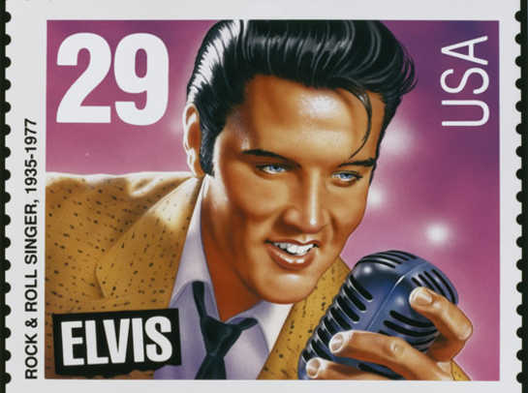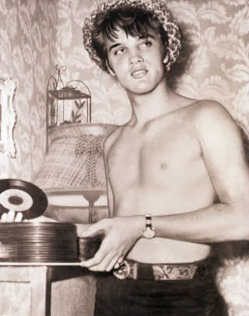
Presley's Memphis home, Graceland, is open to the public, and numerous fans from around the world visit the legendary residence annually, especially around Presley's birthday and the anniversary of his death.
Throughout his amazing career, Presley helped popularize rock 'n' roll music in America. He also won three Grammy Awards for his gospel recordings. Presley had 18 No. 1 singles, including "Don't Be Cruel," "Good Luck Charm" and "Suspicious Minds," as well as countless gold and platinum albums.
He was one of the first performers inducted into the Rock and Roll Hall of Fame (1986) and has been recognized for his contributions to several musical genres, most notably rock, country and gospel.

Marriage and family
Raised by loving, working-class parents, Presley's family had little money. He was deeply devoted to his parents, especially his mother, Gladys, and was raised to have a strong faith in God. Presley attended the Assembly of God Church with his parents, where gospel music became an important influence for him.
He later changed the spelling of his middle name to the biblical form of Aaron. Presley was supposed to be a twin, but his brother, Jesse Garon (sometimes spelled Jessie) was stillborn.
Presley received his first guitar as a gift from his mother on his 11th birthday in 1946 and had his first taste of musical success a few years later when he won a talent show at Humes High School in Memphis.
He received his draft notice in 1957, and was inducted into the Army the following March. He eventually served in Germany for about a year and a half. Shortly before Presley left for Europe, his beloved mother, Gladys, died. He was granted a leave and returned to Memphis for the funeral. Deeply saddened by her death, Presley returned to duty. While in Germany, his spirits were lifted slightly when he met a young teenager named Priscilla Beaulieu.
Presley married Priscilla Beaulieu in 1967 but later divorced in 1973. The couple had one daughter together, Lisa Marie, who was born in 1968.
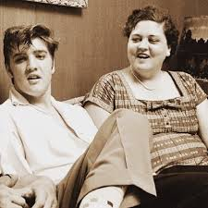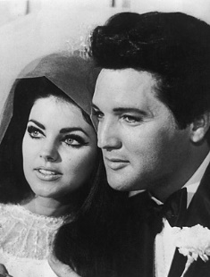
Fame
After graduating in 1953, he worked a number of jobs while pursuing his musical dream. He cut his first demo record at what later became known as Sun Studio that year, and before long, Sam Phillips, the record label owner, decided to take the young performer under his wing.
Presley soon began touring and recording, trying to catch his first big break. "That's All Right" was Presley's first single in 1954.
In 1955 Presley began to develop a following with fans being drawn to his unusual musical style, provocative hips and good looks. That same year, he signed with RCA Records, a deal worked out by his manager, Colonel Tom Parker.
Presley was on a roll, scoring his first No. 1 single with "Heartbreak Hotel," as well as his first No. 1 album, Elvis Presley, and signing a movie contract with Paramount Pictures — all in 1956. Despite the uproar that his sexy dance moves caused, he also became a popular guest on a number of television variety shows.
Soon, Presley was everywhere — on the radio, television and the silver screen — working as a musician and actor.
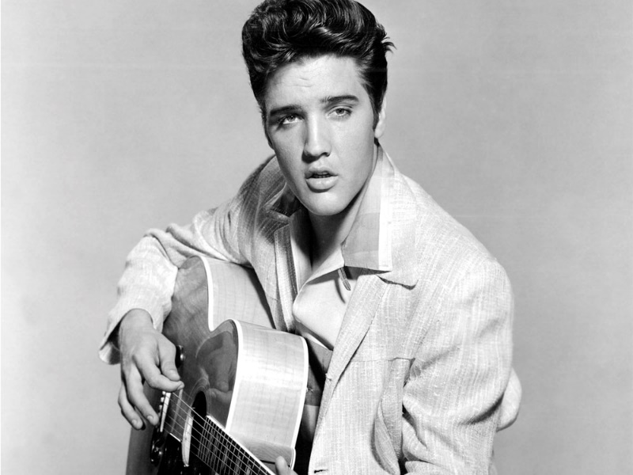
1956-1973
His first film, Love Me Tender (1956), was a box office hit. Even a stint in the U.S. military couldn't put a damper on Presley's thriving career.
After leaving the Army in 1960, Presley resumed his career and was soon back at the top of the charts with the soundtrack for his film GI Blues. He continued recording music and acting in such films as Blue Hawaii (1961), Girls! Girls! Girls! (1962) and Viva Las Vegas (1964).
By the late 1960s, however, he appeared to be losing his box office appeal. Proving he was still the "King of Rock 'n' Roll," he recorded his first TV special in 1968, often referred to as the "'68 Comeback."
Around this time, Presley's personal life also seemed to be on an upswing. He and Priscilla wed in 1967 and had a daughter, Lisa Marie, the following year. Unfortunately, this joyous time would not last. The couple divorced in 1973, and Priscilla received custody of Lisa Marie.
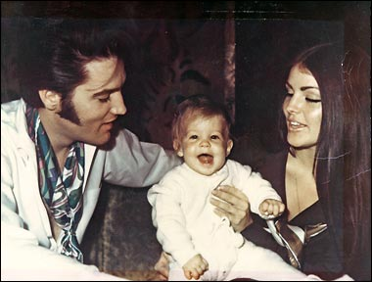

Problems and death
Presley was also wrestling with other personal problems, including a growing addiction to prescription drugs; the once-thin rock star was battling a weight problem, and his destructive lifestyle caught up with him that fall, when he was hospitalized for drug-related health problems.
Despite his personal obstacles, Presley remained a popular draw in Las Vegas and on tour. He performed at his last concert in June 1977, in Indianapolis, Indiana.
Sometime in the morning of August 16, 1977, Presley died of heart failure, at the age of 42. It was later ruled that his death was related to his prescription drug use. Presley was buried on the Graceland property, near the gravesites of his mother, Gladys, father Vernon and grandmother Minnie Mae Hood Presley.
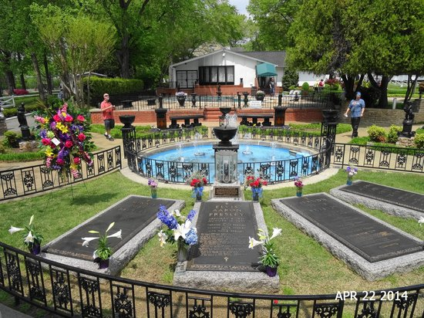

1

Tom Jones is a __________________ (nationality) rock, pop and soul singing legend best known as an international hit maker over the last five decades. Elvis Presley is an ____________________ artist and one of the biggest names in rock 'n' roll.

Tom Jones was born in ___________ (year) and Elvis Presley was born in _____________.
Both of their parents were from ________________ class families.
As a child in school, Tom struggled with _____________________ and was also diagnosed with ________________________ at the age of 12 and was kept quarantined at home for an extensive period of time.
The couple divorced in 1973, and Priscilla received __________ of Lisa Marie.
Presley was also wrestling with other personal problems, including a growing addiction to _______________________; the once-thin rock star was battling a ________________ problem, and his destructive lifestyle caught up with him that fall, when he was hospitalized for drug-related health problems.
For Tom, with success came a U.S. appearance on The _________________________- Show.
In 2012 Jones became a judge on the U.K. reality show ________________.
2

Presley's Memphis home, ____________________, is open to the public, and numerous fans from around the world visit it regularly.
"_______________________," is Tom’s track which attracted the attention the feminist movement.
Jones spent much of the 1970s setting up shop in Las Vegas, hanging out with _______________________, touring and launching a record label, MAM Records, with his manager. In 1999 he released two hits: "Mama Told Me Not to ___________________" and "____________________ Bomb."
Presley was supposed to be a twin, but his brother, Jesse Garon (sometimes spelled Jessie) was _________________.
Other Tom’s highlights included a performance for President ___________________ at the White House Millennium Celebration and for Britain’s monarchy for the ___________________Golden __________________.
In 2015, he released his _______________ studio album Long Lost Suitcase to generally positive reviews.
Jones married his childhood love Melinda "Linda" Trenchard in 1957 at age 16 and remained together for nearly ____________ years until Trenchard died from cancer in 2016.

3

As a teen, Jones was more interested in ________________ and ________________rather than his education, and quit school at age 16.
Presley his first taste of musical success a few years later when he won a ________________ show at Humes High School in Memphis.
Tom’s second single, the groovy, carefree "It's Not ______________________," peaked at No. 1 on the British charts in 1965 and was an American top 10 hit.
Elvis received his draft notice in 1957 and has served in _____________ for about a year and a half. While there, his spirits were lifted slightly when he met a young teenager named _______________ Beaulieu.
The couple had one daughter together, _______________________, who was born in 1968.
Elvis won three Grammy Awards for his gospel recordings. Presley had ____________ No. 1 singles, including "Don't Be Cruel," "Good Luck Charm" and "____________________________," as well as countless gold and platinum albums.
Tom changed his first name from Thomas and his last name from ___________________ to Jones.
He was one of the first performers inducted into the Rock and Roll ________________ (1986) and has been recognized for his contributions to several musical genres, most notably rock, country and gospel.
4

Presley soon began touring and recording, trying to catch his first big break. "That's _______________" was Presley's first single in _________.
Presley was on a roll, scoring his first No. 1 single with "_____________ Hotel".
For his musical accomplishments, Queen Elizabeth II ____________________ him in 2006.
Elvis changed the spelling of his middle name from _____________ to _______________ to make it sound more Biblical.
His first film, ______________Me __________ (1956), was a box office hit. He continued recording music and acting in such films as Blue Hawaii (1961), _________________ (1962) and __________________(1964).
Despite his personal obstacles, Presley remained a popular draw in Las Vegas and on tour. He performed at his last concert in _______________, in Indianapolis, Indiana.
Presley attended the ___________________ of God Church with his parents, where _______________ music became an important influence for him.
Sometime in the morning of August 16, _______________, Presley died of __________________ failure, at the age of 42. It was later ruled that his death was related to his prescription drug use.

