_________________________ number of children in van Gogh family  _________________________ Vincent’s brother who took care of him  _________________________ French city with great light for painting  _________________________ Vincent used this to cut his earlobe off  _________________________ painting Vincent’s brother sold  _________________________ colour of the house Vincent lived in  _________________________ country where Vincent was born in  _________________________ were a group of artists Vincent admired  _________________________ artist who lived with Vincent in France  _________________________ Vincent lived here with a prostitute (The)  _________________________ Vincent wanted to study this field | 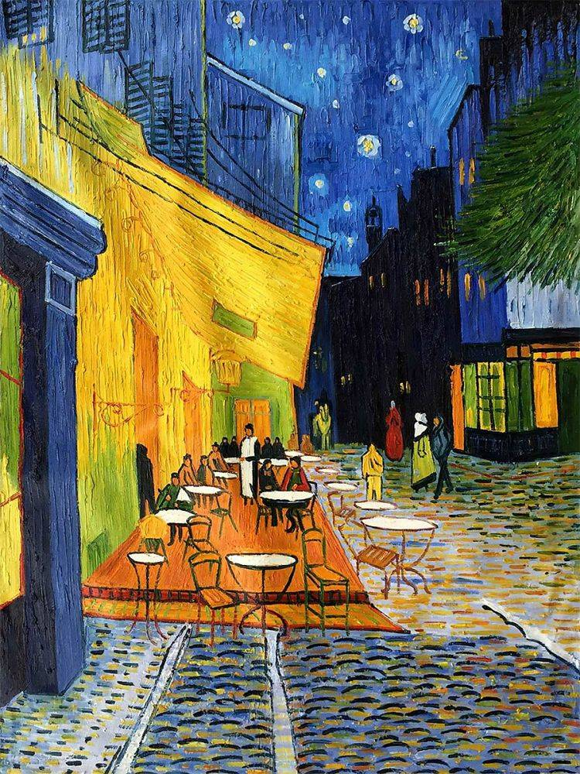
_________________________ number of children in van Gogh family  _________________________ Vincent’s brother who took care of him  _________________________ French city with great light for painting  _________________________ Vincent used this to cut his earlobe off  _________________________ painting Vincent’s brother sold  _________________________ colour of the house Vincent lived in  _________________________ country where Vincent was born in  _________________________ were a group of artists Vincent admired  _________________________ artist who lived with Vincent in France  _________________________ Vincent lived here with a prostitute (The)  _________________________ Vincent wanted to study this field | 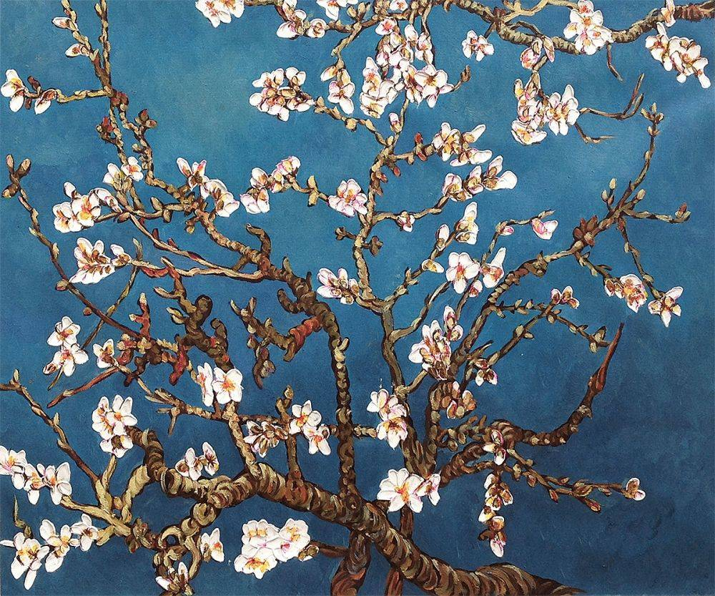
_________________________ number of children in van Gogh family  _________________________ Vincent’s brother who took care of him  _________________________ French city with great light for painting  _________________________ Vincent used this to cut his earlobe off  _________________________ painting Vincent’s brother sold  _________________________ colour of the house Vincent lived in  _________________________ country where Vincent was born in  _________________________ were a group of artists Vincent admired  _________________________ artist who lived with Vincent in France  _________________________ Vincent lived here with a prostitute (The)  _________________________ Vincent wanted to study this field | 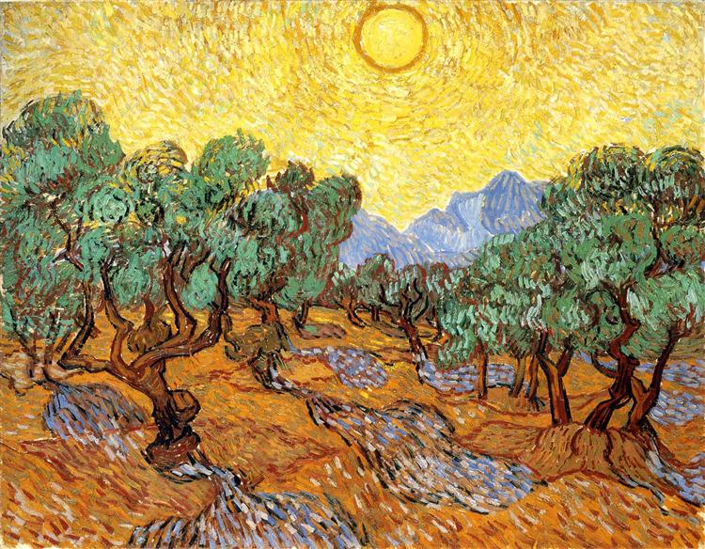

_________________________ number of children in van Gogh family  _________________________ Vincent’s brother who took care of him  _________________________ French city with great light for painting  _________________________ Vincent used this to cut his earlobe off  _________________________ painting Vincent’s brother sold  _________________________ colour of the house Vincent lived in  _________________________ country where Vincent was born in  _________________________ were a group of artists Vincent admired  _________________________ artist who lived with Vincent in France  _________________________ Vincent lived here with a prostitute (The)  _________________________ Vincent wanted to study this field | 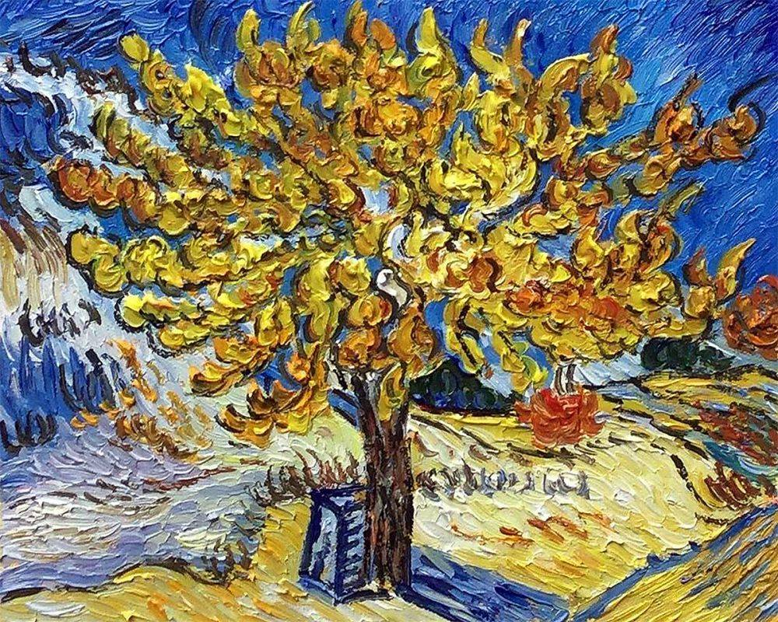
_________________________ number of children in van Gogh family  _________________________ Vincent’s brother who took care of him  _________________________ French city with great light for painting  _________________________ Vincent used this to cut his earlobe off  _________________________ painting Vincent’s brother sold  _________________________ colour of the house Vincent lived in  _________________________ country where Vincent was born in  _________________________ were a group of artists Vincent admired  _________________________ artist who lived with Vincent in France  _________________________ Vincent lived here with a prostitute (The)  _________________________ Vincent wanted to study this field | 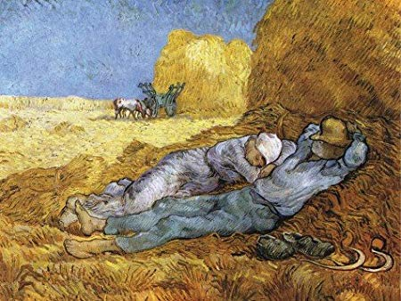
_________________________ number of children in van Gogh family  _________________________ Vincent’s brother who took care of him  _________________________ French city with great light for painting  _________________________ Vincent used this to cut his earlobe off  _________________________ painting Vincent’s brother sold  _________________________ colour of the house Vincent lived in  _________________________ country where Vincent was born in  _________________________ were a group of artists Vincent admired  _________________________ artist who lived with Vincent in France  _________________________ Vincent lived here with a prostitute (The)  _________________________ Vincent wanted to study this field | 